H1: Secure Sign-in Transition

VA is updating our sign-in process to support the president’s cybersecurity executive order.

> [Read the President’s Executive Order](https://www.whitehouse.gov/briefing-room/presidential-actions/2021/05/12/executive-order-on-improving-the-nations-cybersecurity/)

# H2: Why this matters

We are updating how you sign in to VA websites. As of December 1, 2024, you’ll need to use a verified Login.gov or ID.meaccount that meets our new, stronger security requirements. You’ll no longer be able to use your DS Logon or My HealtheVet username and password to sign in to VA websites or applications.

# H2: Use your Login.gov or ID.me account to sign in

We encourage you to create a free Login.gov or ID.me account now. Or, if you already have one of these accounts, start using it so you have plenty of time to get used to it before the change. With Login.gov or ID.me, you’ll have access to all the same information and services that you use today.

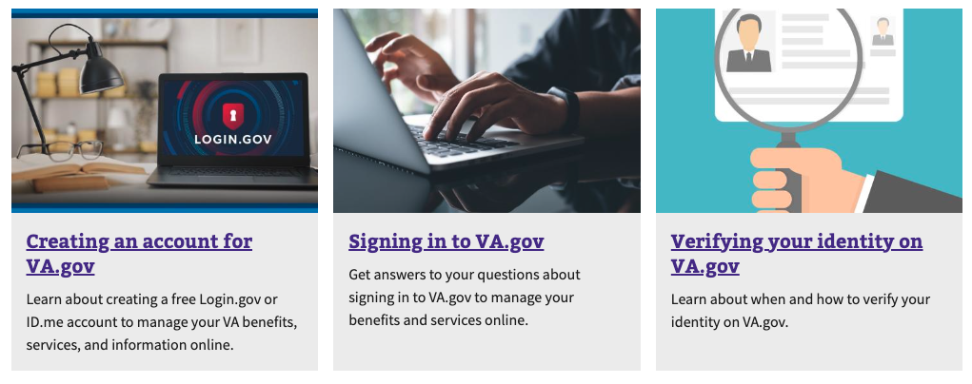

# H2: Keep up-to-date with the latest on sign-in changes at VA

Here you can find the latest updates on changes to the sign-in process published on VA News.

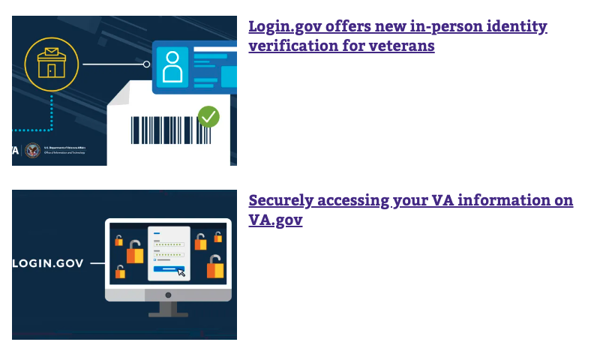

# H2: Frequently asked questions

**How do I sign in to VA.gov?**

At this time, you can sign in to VA.gov with any of these 4 accounts:

* Login.gov
* ID.me
* My HealtheVet
* DS Logon

If you don’t have an account, you can create a Login.gov or ID.me account now.

Note: In about a year, on December 1, 2024, you’ll no longer be able to sign in with your My HealtheVet or DS Logon username and password. You’ll need to use either a Login.gov or ID.me account.

**What type of account should I create to manage my VA benefits online?**

We encourage you to create a Login.gov or ID.me account. Starting in about a year, on December 1, 2024, these 2 accounts will be the only accounts we’ll allow for signing in to VA.gov and other VA online services.

Both of these accounts meet modern security standards. Both accounts protect your data at 2 levels—so only you can access and change your stored information. And both Login.gov and ID.me let you use a single, secure account to access to your VA benefits, services, and information.

You can also use your Login.gov or ID.me account to manage some other government benefits and services (like Social Security benefits).

Login.gov is a U.S. government account provider. ID.me is a private account provider that partners with the U.S. government.

[Create a Login.gov account](https://api.va.gov/v1/sessions/logingov_signup/new)

[Create an ID.me account](https://api.va.gov/v1/sessions/idme_signup/new?op=signup)

**Why will VA allow only 2 sign-in account options as of December 2024?**

Here’s why we’re transitioning to only 2 modern, secure sign-in account options (Login.gov or ID.me) by December 1, 2024:

Identity theft and related medical identity theft are serious issues that can cause severe financial hardship and disruption in medical care for Veterans and their families. In 2022, the Federal Trade Commission (FTC) received more than 1.1 million reports of identity theft. And Veterans, service members, and their spouses reported more than 193,000 cases of identity theft and fraud.

We’re required by law to help all Veterans begin using a sign-in account that meets modern security standards of identity verification and multifactor authentication. Login.gov and ID.me accounts both better meet these standards than using a My HealtheVet or DS Logon username and password.

Veterans have told us many times over several years that they want fewer account options—and they want to be able to use their chosen sign-in account to access all of their VA benefits and care.

**Will I have to add multifactor authentication by December 2024?**

Yes. Both Login.gov and ID.me require multifactor authentication (MFA) as part of the account set-up process. This extra layer of protection helps us make sure that it’s you trying to access your account—and not a scammer.

Multifactor authentication is a common practice for many websites and apps. You may already use it to access your email, bank account, or social media accounts.

When you set up your Login.gov or ID.me account, you can choose the multifactor authentication option that works best for you.

[Go to Login.gov’s guide to multifactor authentication options](https://www.login.gov/help/get-started/authentication-methods/)

[Go to ID.me’s guide to multifactor authentication options](https://help.id.me/hc/en-us/articles/360018113053-Getting-started-with-multi-factor-authentication-MFA-)

**Can I still use a DS Logon or My HealtheVet account to sign in?**

Yes. At this time, you can use your DS Logon or My HealtheVet account to sign in. But to manage certain tasks and information on VA.gov, you’ll need to create a Login.gov or ID.me account and verify your identity.

We do encourage you to create a Login.gov or ID.me account now. In about a year, on December 1, 2024, we’ll transition to only these 2 modern, secure account options for VA.gov and other VA online services. You’ll then no longer be able to use your DS Logon or My HealtheVet account. Create your new account now so you have plenty of time to get used to it before this change.

How can I get help with creating an account or signing in to my existing account?

If you need help creating a Login.gov or ID.me account or experience issues with signing in to your existing account, you can call the Login.gov help center at 844-875-6446 (TTY: 711). They’re open 24/7. You can also submit a help ticket on the Login.gov or ID.me website.

[Go to the Login.gov help center](https://login.gov/help/)

[Go to the ID.me help center](https://help.id.me/hc/en-us)